1. 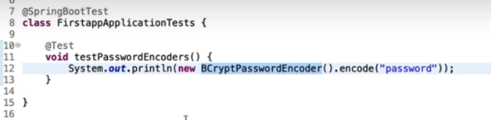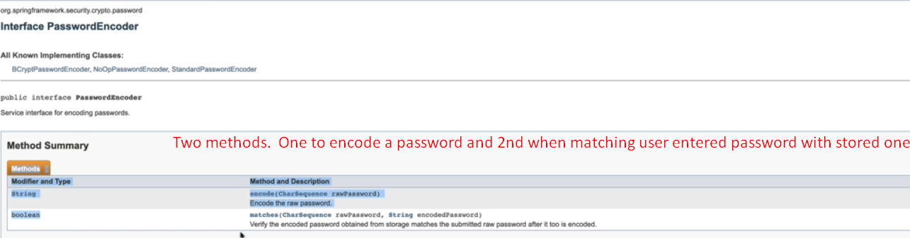
2. PasswordEncoder.matches(rawPassword, encodedPassword) is invoked by AuthenticationProvider.
3. 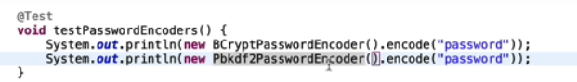
4. 